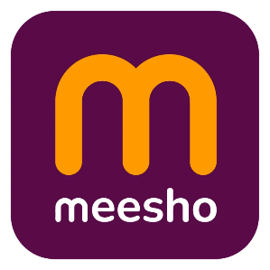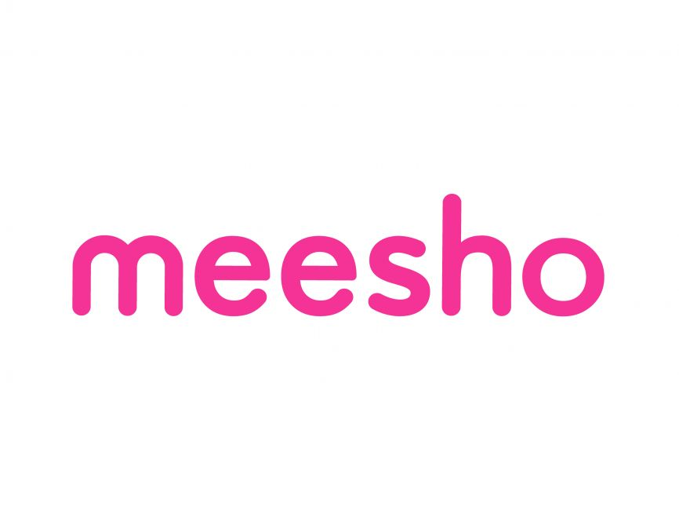

Product Dissection for Meesho

Company Overview:
Meesho is an Indian e-commerce giant that has carved out a unique space by focusing on "value commerce"—affordable, unbranded products tailored for Tier-2, Tier-3, and Tier-4 cities. Originally a social commerce platform for WhatsApp resellers, it has evolved into a massive direct-to-consumer marketplace that competes with players like Amazon and Flipkart.
As of early 2026, Meesho has recently undergone a major milestone by launching its Initial Public Offering (IPO) in December 2025

Feature | Details
Founded | 2015 (Initially as "Fashnear")
Headquarters | Bengaluru, India
Founders | Vidit Aatrey (CEO) and Sanjeev Barnwal (CTO)
Market Valuation | ~₹52,500 – ₹53,000 Crore (~$6 Billion)
Key Categories | Fashion, Home & Kitchen, Beauty & Personal Care
Revenue (FY25) | ₹9,900 Crore

Business Model: The "Zero Commission" Strategy:
Unlike traditional marketplaces that take a cut of every sale, Meesho operates on a logistics and ads-led model:
- Zero Commission: It does not charge sellers a commission to list or sell, making it highly attractive to small-scale manufacturers and "homepreneurs."
- Revenue Streams: Income is primarily generated through logistics fees (via its in-house arm, Valmo) and advertising services where sellers pay for better visibility.
- Meesho Mall: A newer segment for branded products where it does charge a small platform fee (2-5%).
- Discovery-Led Shopping: The app is designed for browsing and discovery—similar to a social media feed—rather than just specific intent-based searching.

Product Dissection and Real-World Problems Solved by Meesho:

Meesho has effectively addressed significant barriers to entrepreneurship and online shopping in India through its innovative platform.

Case Study: Real-World Problems and Meesho's Innovative Solutions
Meesho, India's fastest-growing social commerce platform, has not only revolutionised the way value-seeking consumers shop but has also addressed significant socio-economic challenges through its innovative features. By identifying the unique needs of the "Bharat" market (Tier-2+ cities) and leveraging a mobile-first technology stack, Meesho has positioned itself as a solution-driven platform that fosters micro-entrepreneurship, encourages financial independence, and democratizes e-commerce.

Problem 1: High Entry Barriers for Small Entrepreneurs
Real-World Challenge: Starting a retail business traditionally requires heavy capital for inventory, shop space, and marketing, making it inaccessible for millions (especially homemakers and students).
Meesho's Solution: By providing a Zero-Investment model, Meesho allows resellers to share products from suppliers directly on social media (WhatsApp, Facebook, Instagram etc.). The platform handles logistics and payments, empowering users to become entrepreneurs without financial risk.

Problem 2: Trust Deficit in E-commerce
Real-World Challenge: Many consumers in smaller towns are hesitation of buying from faceless online corporations.
Meesho's Solution: Leveraging social commerce. When a consumer buys through a friend or relative (a reseller), the inherent trust in that personal relationship bridges the gap between digital interaction and a genuine purchase, encouraging first-time online shoppers to join the ecosystem.

Problem 3: Information Overload and Content Discovery
Real-World Challenge: The sheer volume of online goods makes it difficult for value-conscious buyers to find affordable, relevant fashion and home decor.
Meesho's Solution: Through its curated catalogs and personalized recommendations, Meesho simplifies discovery. The app organizes products into easy-to-browse categories, helping resellers find items that specifically appeal to their local community's tastes.
Problem 4: Information Overload & Discovery in Value Shopping
Real-World Challenge: Large e-commerce platforms often prioritize big brands, making it difficult for budget-conscious consumers to find unbranded, high-quality, and affordable "value" products tailored to regional tastes.
Meesho's Solution: Meesho's curated "Explore" and "Community" features use data-driven algorithms to suggest trending, high-value items based on regional preferences. By categorizing products into niche catalogues that are easily "shareable," Meesho solves the problem of discovery. Users don't have to sift through millions of irrelevant items; they see what is trending in their specific social or regional circles.
Real-World Problem | Meesho’s Structural Solution
Trust Issues | Social sharing via WhatsApp & reliable COD.
Price Sensitivity | 0% commission for sellers to keep end-prices lowest.
Accessibility | Lite app for low-end smartphones and vernacular UI.
Seller Friction | Simple onboarding for small local boutiques/manufacturers.

Conclusion:
Meesho's journey from a localized reselling tool to a national marketplace is a testament to its ability to identify deep-seated structural problems in the Indian economy and provide tech-enabled solutions. By fostering financial independence for women, building trust through social networks, and simplifying logistics for small suppliers, Meesho has reshaped the digital landscape for the next billion users.

Top Features of Meesho:
- Reseller Catalogs: A vast collection of products that can be shared instantly with custom profit margins.
- Meesho Community: A space for entrepreneurs to learn, share success stories, and gain business insights.
- Integrated (Valmo) Logistics: A seamless system that manages pickup from suppliers and delivery to the end customer.
- User Profiles: Separate dashboards for resellers to track their earnings, margins, and customer orders.
- Search & Filters: Optimized tools to find niche products across diverse categories like ethnic wear, electronics, and home utilities.

Meesho Schema Description:
The database schema for Meesho involves entities representing the marketplace dynamics between Suppliers, Resellers, and Customers.
1. User Entity (Multi-Role)
Users are the backbone of Meesho. A user can be a Reseller, a Customer, or both.
UserID (PK): Unique identifier for each user.
Username: Account handle.
Email/Phone: Contact for OTP verification and order updates.
User_Type: Identifies if the user is primarily a Reseller or Customer.
Registration_Date: When the user joined the platform.
2. Product Entity
Captures the items listed by suppliers.
ProductID (PK): Unique identifier for each product.
SupplierID (FK): References the supplier providing the item.
Price: The base cost of the product.
Image_URL: Links to the product visuals.
Category: The grouping (e.g., "Sarees," "Kitchen Tools",” Electronics”).
3. Order Entity
Manages the transaction between all three parties.
OrderID (PK): Unique identifier for the transaction.
CustomerID (FK): The end-user receiving the product.
ResellerID (FK): The entrepreneur who facilitated the sale.
Total_Price: Base price + Reseller margin.
Order_Status: Tracking (Pending, Shipped, Delivered).
4. Shared_Product Entity (Interaction)--
Tracks social commerce engagement.
ShareID (PK): Unique ID for a "share" action.
ResellerID (FK): The user sharing the item.
ProductID (FK): The item being shared.
Platform: Where it was shared (WhatsApp, Facebook, Instagram, Messages etc.)
ER Diagram:
Let's construct an ER diagram that vividly portrays the relationships and attributes of the entities within the Meesho schema. This ER diagram will serve as a visual representation, shedding light on the pivotal components of Meesho's data model. By employing this diagram, you'll gain a clearer grasp of the intricate interactions and connections that define the platform's dynamics.
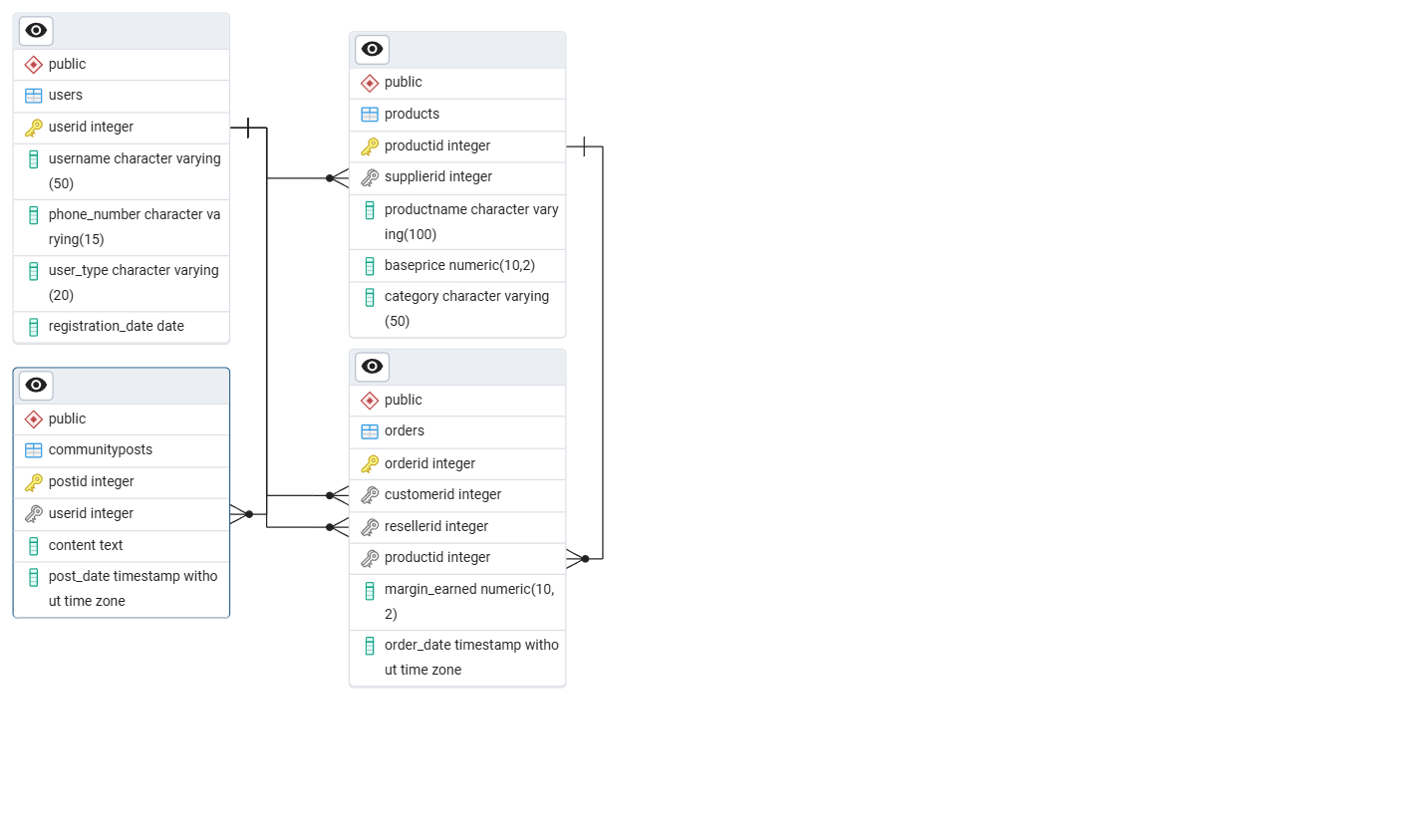

Conclusion:
Meesho’s schema is designed to handle the complexity of three-way transactions (Supplier-Reseller-Customer). By prioritizing a user-centric data model, Meesho effectively manages the lifecycle of a product from a small supplier’s warehouse to a customer's doorstep, all while enabling a local entrepreneur to earn a livelihood.
Meesho's transition from a simple reselling tool to a massive e-commerce ecosystem demonstrates the power of solving for "unserved" markets. By removing financial risk for entrepreneurs and building a logistics backbone for small suppliers, Meesho hasn't just built an app; it has built a digital economy for millions of Indians.

